RESOLUTION NO.__________

RE: CERTIFICATE OF APPROPRIATENESS UNDER THE
PROVISIONS OF THE ACT OF THE PENNSYLVANIA
LEGISLATURE 1961, JUNE 13, P.L. 282 (53
SECTION 8004) AND BETHLEHEM ORDINANCE NO.
3952 AS AMENDED.

The applicant proposes to install vinyl lettering on the storm door at the entrance and to install an awning above the storefront at 530 Main St.

NOW, THEREFORE, BE IT RESOLVED by the Council of the City of Bethlehem that a Certificate of Appropriateness is hereby granted for the proposal.

Sponsored by: (s)

(s)

ADOPTED BY COUNCIL THIS DAY OF

(s)
President of Council

ATTEST:

(s)
City Clerk

HISTORICAL & ARCHITECTURAL REVIEW BOARD

The applicant proposes to install vinyl lettering on the storm door at the entrance and to install an awning above the storefront at 530 Main St.

APPLICATION #2:

Steve Holloman
P.O. Box 1024
Bethlehem, PA 18016
OWNER:

__________________________________________________________________________

The Board upon motion by Connie Glagola and seconded by Beth Starbuck adopted the proposal that City Council issue a Certificate of Appropriateness for the following:

- New vinyl sign on the storm door with reduced size to 14” x 18” with color to be
Off-white.

2. Awning to be Navy Blue with off-white logo on sloped portion with scalloped or
straight bottom edge and closed ends.

3. The motion was unanimously approved.

__________________________________________________________________________

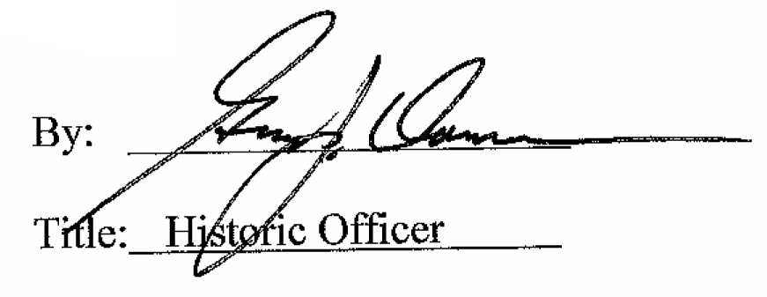

Date of Meeting: March 14, 2018

